Student’s Name
Institutional Affiliation
Course Name
Instructor’s Name
Date

SN2 reactions
A SN2 reaction is a type of chemical reaction in organic chemistry where a nucleophile (nuclear loving) that is negatively charged substitutes an atom of a halogen which is bonded to the central carbon of an alkyl halide molecule. The saturated carbon in the organic compound is the one that participates in the reaction.
Nucleophiles that can displace the halogen include halide, alkoxy group hydroxyl group, hydrogen sulphide, water, ammonia and cyanide ion.
One particular example of a SN2 reaction is that involving sodium hydroxide and ethyl bromide. The reaction yields Ethanol and sodium bromide.
CH₃CH₂Br(aq)+NaOH(aq)⇌CH₃CH₂OH(aq)+NaBr(aq)
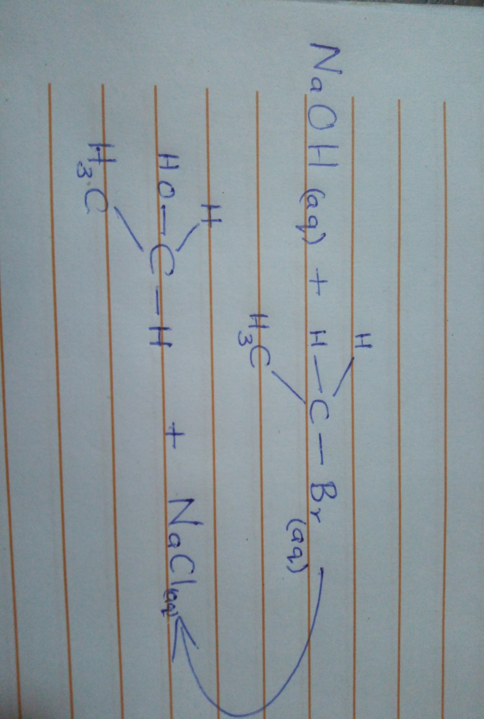
Mechanism
The mechanism involves the attack of the ethyl bromide (substrate) by the hydroxyl (nucleophile) from the backside (180 degrees approach). Carbon-halogen break as the carbon-nucleophile bond forms.
Step 1: Backside attack by the nucleophile (OH) to form the intermediate compound (Carbanion)
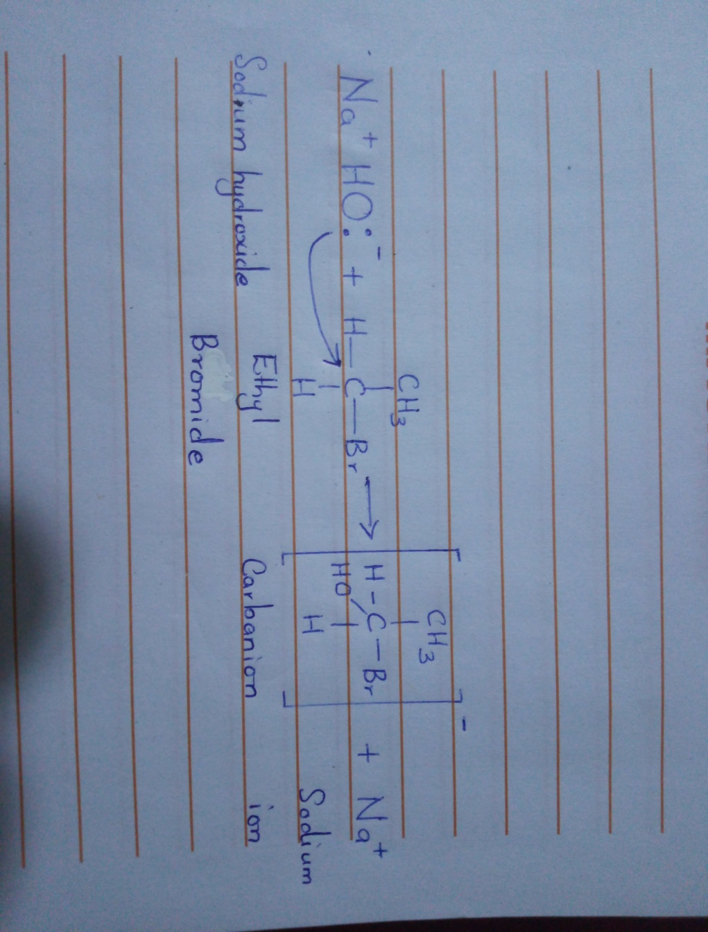
The second step involves the simultaneous breaking of carbon-bromide bond to form ethanol and sodium bromide.
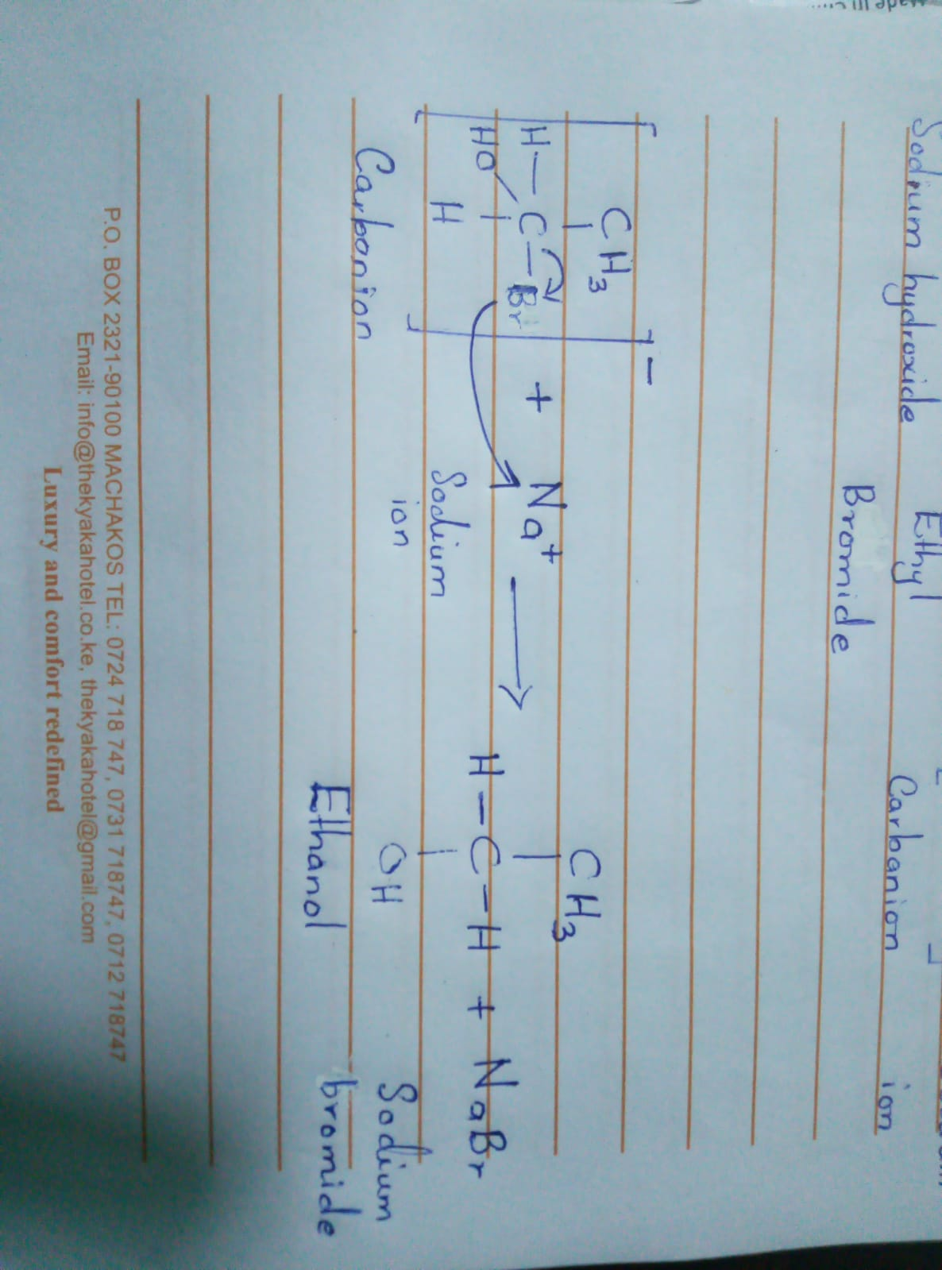
Conditions
These reactions require good leaving groups such as weak bases.
SN2 reactions occur in primary and secondary alkyl halides but not tertiary halides as the carbon is almost immune to nucleophilic attack.
Polar aprotic solvents enhance the reaction rate hence can be applied (Hamlin, 2018). However polar protic solvents hinder reactivity as the latter hinder the hydroxyl from participating in the reaction.
The nucleophile attacks primarily from the backside because the front side is obscured by the electron-rich bromide (leaving group).
Effect on Stereochemistry
The backside attacks of SN2 reactions result in the inversion of the product in comparison to the substrate.
SN1 Reactions
SN1 reactions resemble SN2 reactions in that the nucleophile attacks the carbon of an alkyl halide in a nucleophilic substitution reaction; however, the reaction is stepwise and not simultaneous as with SN2 reactions.
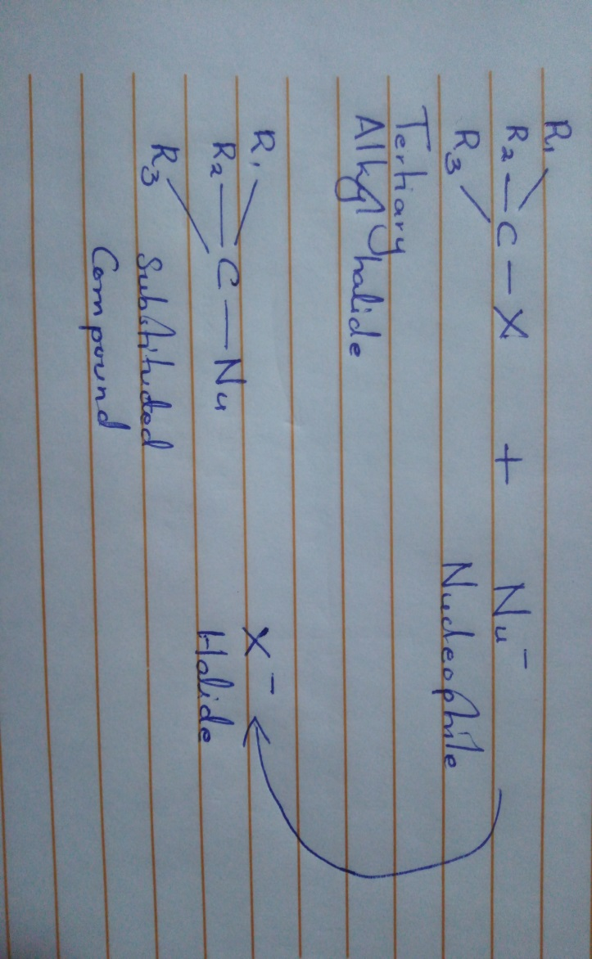
Mechanism
The first step involves the formation of the carbacation by the removal of the leaving group (when carbon-halogen bond is broken. In the second step, the carbacation is attacked by the nucleophile to form and intermediate (oxonium). In the final step deprotonation of the protonated nucleophile occurs once more to form hydronium ion and alcohol.
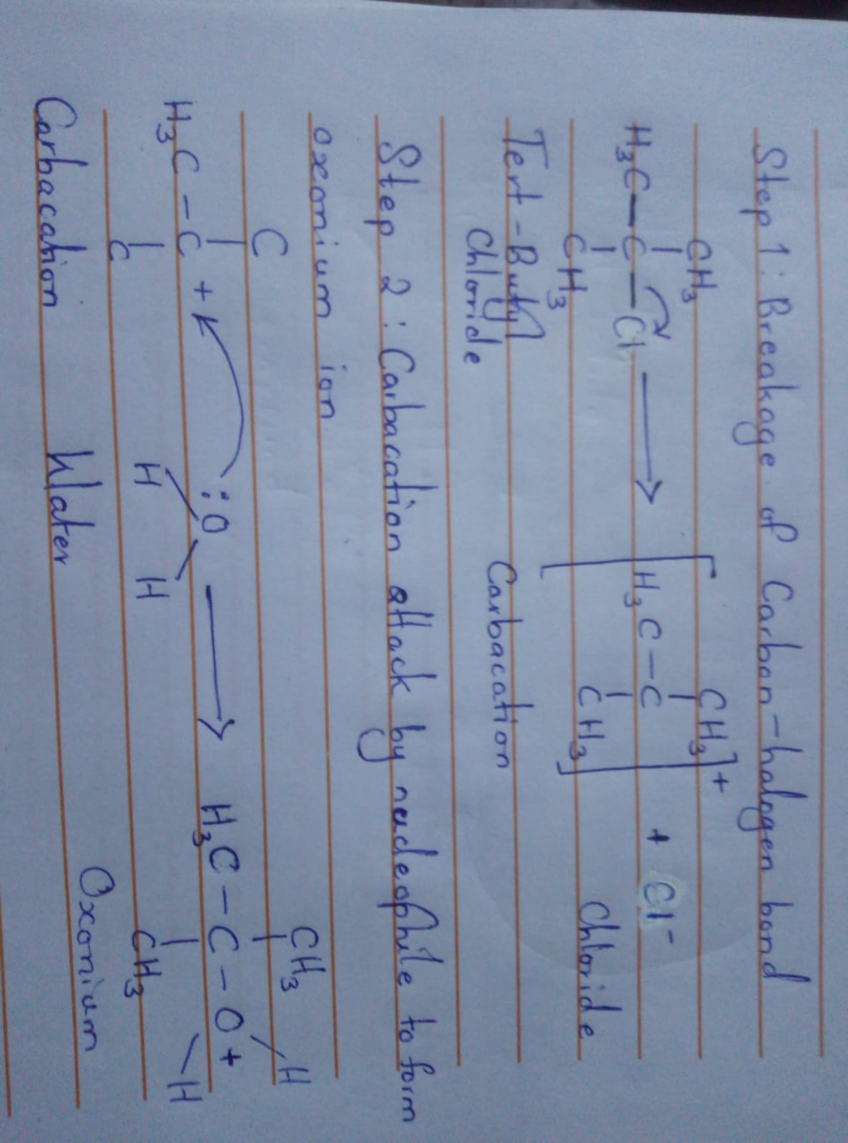
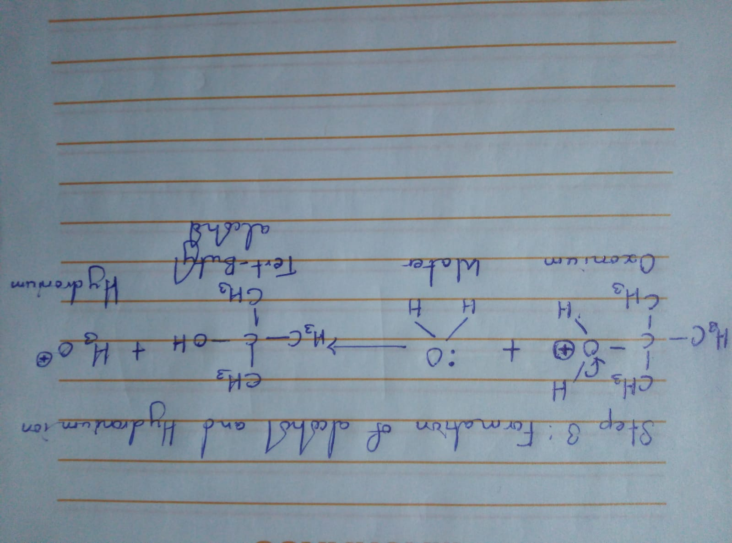
Conditions
As with SN2 reactions, SN1 reactions do require a suitable leaving group that dissociates easily. As such a weak base makes a good leaving group.
The order of reactivity of halogens towards these reactions is I>Br>Cl>F.
Polar protic solvents (water or alcohol) immensely accelerate the reaction as they help in formation of carbacation.
Primary haloalkanes do not undergo SN1 reactions as the intermediate carbacation is hard to produce owing to its instability
Effects on Stereochemistry
The carbacation formed in the first step has a trigonal planar conformation thus it has equal chances of being attacked from all two sides. This normally yields enantiomers that are both left and right-handed in equal proportions.
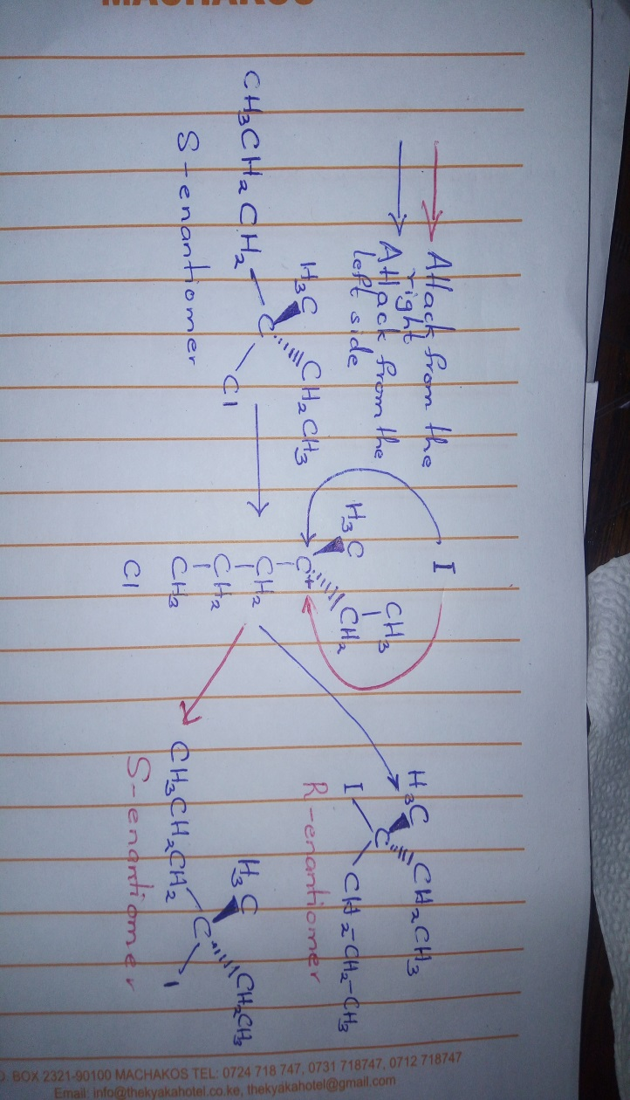
EN2 Reactions
An EN2 reaction is an organic reaction where one substitute is removed/ eliminated from the substrate by a one-step mechanism. This reaction is bi-molecular, that is, a second order reaction.
The following is a representation of and EN2 reaction
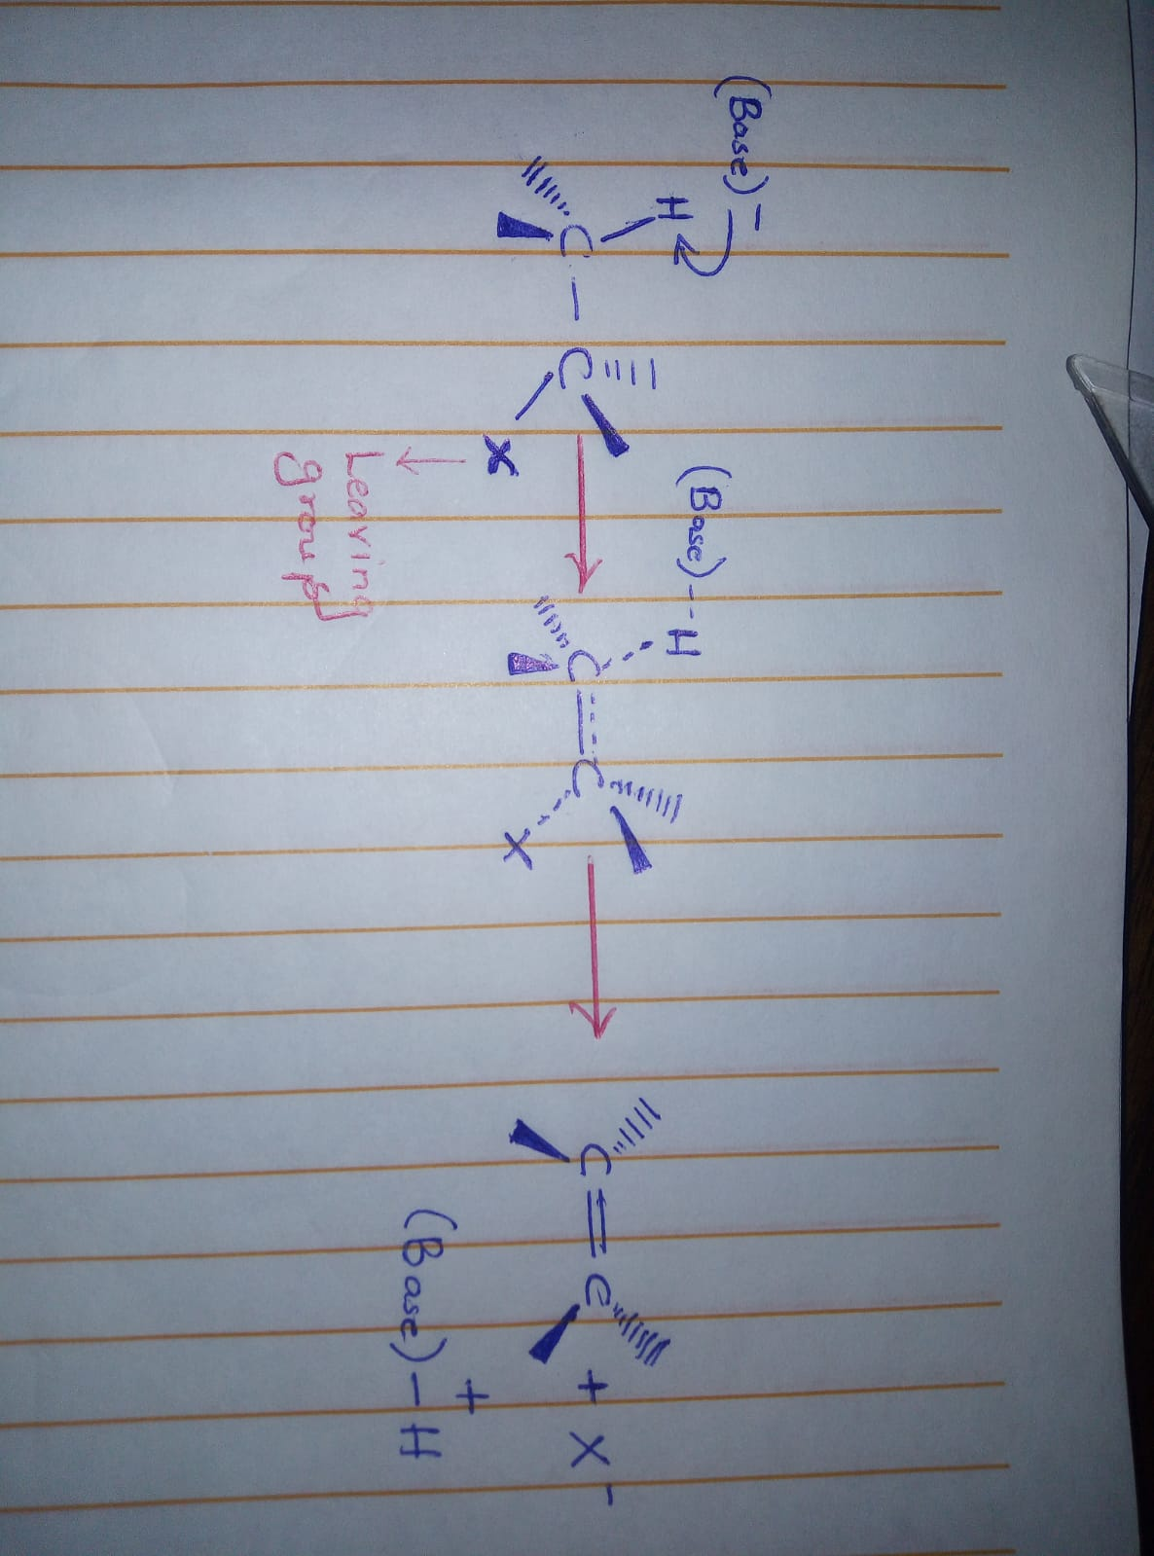
Mechanism
In this reaction, a strong base removes the proton from the alkyl halide as seen above while simultaneously removing the leaving group that is oriented anti to the proton (180 degrees). Such a mechanism is called a concerted mechanism.
An example of such a reaction is illustrated below where tertiary-butylbromide is acted upon by a base.
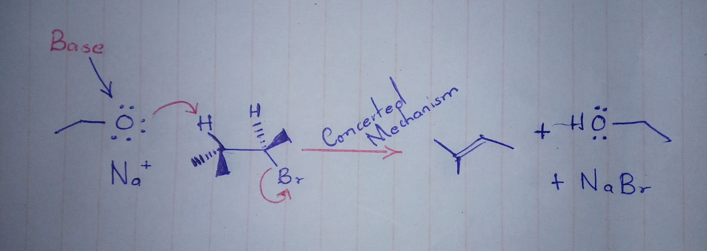
Conditions
Since the reaction results in the formation of a pi bond, the hydrogen and leaving group have to be antiplanar as this conformation requires lesser energy than synperiplanar hence more favourable.
These reactions are favored by higher temperatures (high entropy)
A base strong enough is required to remove the weakly bonded hydrogen.
Mostly undergone by primary alkyl halides; secondary alkyl halides need special conditions.
The reaction rate is influenced by the base and the substrate
Polar aprotic solvents are normally suitable for this reaction.
Effect on Stereochemistry
These reactions require the leaving group to be ant-planar (180 degrees) to the proton that is to be removed by the strong base.
EN1 Reactions
The EN1 reaction is a unimolecular two-step elimination reaction that involves ionization and deprotonation. In ionization, a carbacation intermediate is produced from the break-down of the carbon and halogen bond. The carbacation is further deprotonated.
Tertiary substrates are more favored in this reaction.
Mechanism
The following reaction is an example involving Tertiary butyl bromide and potassium ethanolate (C₂H₅KO). The reaction results in the formation of 2 butene.
Firstly, the leaving group is removed forming a carbacation. Secondly the proton is removed to form an alkene.
The reaction is dependent on substrate concentration and as such the removal of the leaving group is the rate limiting step.
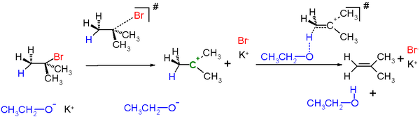

Conditions
The mechanism is favored by acidic conditions and high temperature. Thus, a strong base is not required.
The reaction is also favored by stearic hindrance hence preferred over substitution reactions when the substrate is bulky.
Bases that have steric bulkiness favor EN1 reactions.
Effects on Stereochemistry
The reaction does not have any anti-planar or peri-planar requirements. However it is normally accompanied by the rearrangement of carbacations.

Reference
Britannica, T. Editors of Encyclopaedia (2011, December 16). Elimination reaction. Encyclopedia Britannica. https://www.britannica.com/science/elimination-reaction
Hamlin, Trevor A. et al (2018). "Nucleophilic Substitution (SN 2): Dependence On Nucleophile, Leaving Group, Central Atom, Substituents, And Solvent". Chemphyschem, vol 19, no. 11, , pp. 1315-1330. Wiley, doi:10.1002/cphc.201701363. Accessed 28 Feb 2021.
"7.18: Comparison Of E1 And E2 Reactions". Chemistry Libretexts, 2016, https://chem.libretexts.org/Bookshelves/Organic_Chemistry/Map%3A_Organic_Chemistry_(Wade)/07%3A_Alkyl_Halides%3A_Nucleophilic_Substitution_and_Elimination/7.18%3A_Comparison_of_E1_and_E2_Reactions. Accessed 28 Feb 2021.
"Stereochemistry — Definition And Chirality | Medical Library". The Lecturio Online Medical Library , 2016, https://www.lecturio.com/magazine/stereochemistry/. Accessed 28 Feb 2021.

